Project Design Phase-II
Data Flow Diagram & User Stories

Date | 30 September 2026
Team ID | SWTID-2026-1437
Project Name | AI WeatherWise API
Maximum Marks | 4 Marks

Data Flow Diagrams:
A Data Flow Diagram (DFD) is a traditional visual representation of the information flows within a system. A neat and clear DFD can depict the right amount of the system requirement graphically. It shows how data enters and leaves the system, what changes the information, and where data is stored.
Data Flow Diagram (Level 1) - AI WeatherWise API
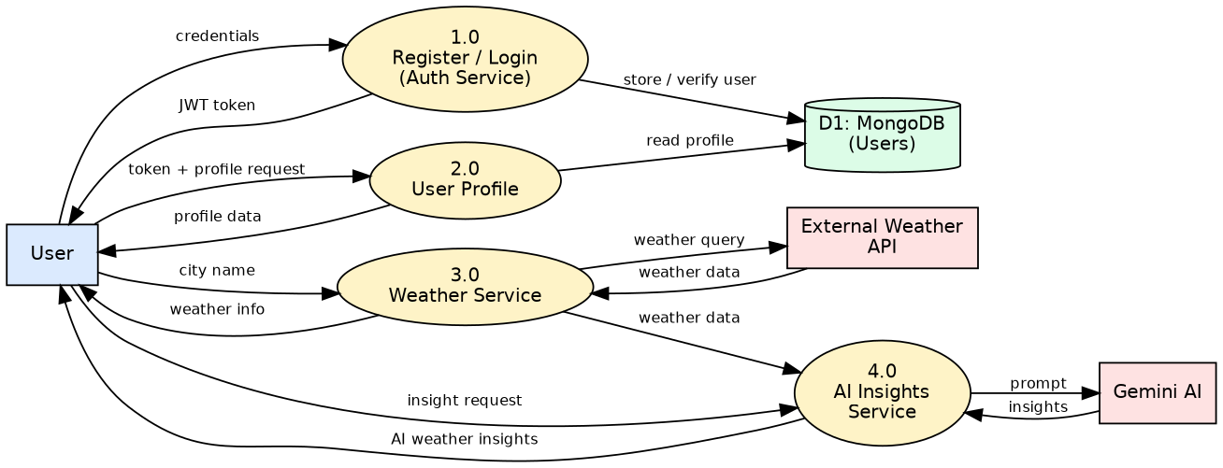
The user sends registration/login details to the Auth Service, which stores or verifies the user in MongoDB and returns a JWT token. Using the token, the user can view the profile and request weather information for a city. The Weather Service fetches data from the external weather API. For AI insights, the weather data is passed to the AI Insights Service, which sends a prompt to Gemini AI and returns the insights to the user.

User Stories
Use the below template to list all the user stories for the product.
User Type | Functional Requirement (Epic) | User Story Number | User Story / Task | Acceptance criteria | Priority | Release
Customer (API user) | Registration | USN-1 | As a user, I can register for the application by entering my name, email and password. | Account is created and a success response is returned | High | Sprint-1
 |  | USN-2 | As a user, I receive a clear error if I try to register with an email that already exists. | Duplicate registration is rejected with an error message | High | Sprint-1
 | Login | USN-3 | As a user, I can log in by entering my email and password and receive an access token. | Valid credentials return a JWT token | High | Sprint-1
 |  | USN-4 | As a user, I am told when my login credentials are wrong. | Invalid credentials return a 401 error and no token | High | Sprint-1
 | Authentication | USN-5 | As a user, I can access protected routes only with a valid token. | Requests without a valid token are rejected | High | Sprint-2
 | User Profile | USN-6 | As an authenticated user, I can view my profile details. | Profile details are returned for the logged-in user | High | Sprint-2
 | Weather Information | USN-7 | As a user, I can get the current weather information for a city. | Weather data for the city is returned | High | Sprint-2
 |  | USN-8 | As a user, I get a proper error message when I search for an invalid city. | 'City not found' error is returned without crashing the API | Medium | Sprint-3
 | AI Weather Insights | USN-9 | As a user, I can get AI-based insights and suggestions for the weather of a city. | Gemini AI insights are generated and returned | High | Sprint-3
 |  | USN-10 | As a user, I get a helpful message if the AI service is unavailable. | API returns a graceful error instead of failing | Medium | Sprint-3
Administrator | Database Operations | USN-11 | As a system, user data is stored and retrieved reliably from MongoDB. | User records are saved and fetched correctly | High | Sprint-3
Customer (API user) | Error Handling & Validation | USN-12 | As a user, I get consistent validation errors for missing or invalid input. | Invalid input returns clear error responses | Medium | Sprint-4
Tester | Testing | USN-13 | As a tester, I can verify all API responses through UAT test cases. | All UAT test cases pass | High | Sprint-4
Developer | Documentation | USN-14 | As a developer, I can read the API usage documentation. | README/API usage guide is available | Low | Sprint-4
Administrator | Deployment | USN-15 | As an administrator, I can run the API with environment-based configuration. | API runs using environment variables for keys and DB URL | Medium | Sprint-4

